**3 Sum**

1. **Screenshot**

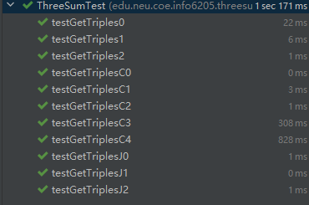

1. **Timing observation**
2. **Explanation**